UNIT V DATA LINK AND PHYSICAL LAYERS
Data Link Layer – Framing – Flow control – Error control – Data-Link Layer Protocols – HDLC – PPP - Media Access Control – Ethernet Basics – CSMA/CD – Virtual LAN – Wireless LAN (802.11) - Physical Layer: Data and Signals - Performance – Transmission media- Switching – Circuit Switching
1. INTRODUCTION

- In the OSI model, the data link layer is the 2nd layer from the bottom.
- It is responsible for transmitting frames from one node to next node.
- The main responsibility of the Data Link Layer is to transfer the datagram across an individual link.
- An important characteristic of a Data Link Layer is that datagram can be handled by different link layer protocols on different links in a path.
- The other responsibilities of this layer are
  - Framing - Divides the stream of bits received into data units called frames.
  - Physical addressing – If frames are to be distributed to different systems on the same network, data link layer adds a header to the frame to define the sender and receiver.
  - Flow control- If the rate at which the data are absorbed by the receiver is less than the rate produced in the sender ,the Data link layer imposes a flow control mechanism.
  - Error control- Used for detecting and retransmitting damaged or lost frames and to prevent duplication of frames. This is achieved through a trailer added at the end of the frame.
  - Medium Access control - Used to determine which device has control over the link at any given time.

Nodes and Links
- Communication at the data-link layer is node-to-node.
- The communication channel that connects the adjacent nodes is known as links, and in order to move the datagram from source to the destination, the datagram must be moved across an individual link.
- A data unit from one point in the Internet needs to pass through many networks (LAN and WAN) to reach another point.
- Theses LANs and WANs are connected by routers.
- The two end hosts and the routers are nodes and the networks in- between are links.

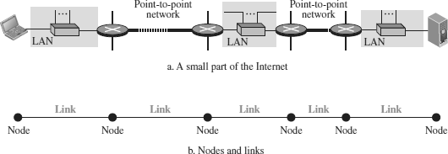

- The first node is the source host; the last node is the destination host.
- The other four nodes are four routers.
- The first, the third, and the fifth links represent the three LANs; the second and the fourth links represent the two WANs.
Two Categories of Links
Point- to-Point link and Broadcast link.
- In a point-to-point link, the link is dedicated to the two devices
- In a broadcast link, the link is shared between several pairs of devices.

Data Link Layer Services
- The data-link layer is located between the physical and the network layers.
- The datalink layer provides services to the network layer; it receives services from the physical layer.
- When a packet is travelling, the data-link layer of a node (host or router) is responsible for delivering a datagram to the next node in the path.
- For this purpose, the data-link layer of the sending node needs to encapsulate the datagram and the data-link layer of the receiving node needs to decapsulate the datagram.
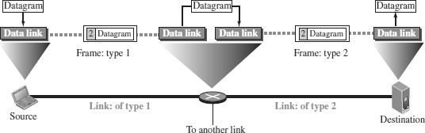
- The datagram received by the data-link layer of the source host is encapsulated in a frame.
- The frame is logically transported from the source host to the router.

- The frame is decapsulated at the data-link layer of the router and encapsulated at another frame.
- The new frame is logically transported from the router to the destination host.

Sublayers in Data Link layer
- We can divide the data-link layer into two sublayers: data link control (DLC) and media access control (MAC).
- The data link control sublayer deals with all issues common to both point- to-point and broadcast links
- The media access control sublayer deals only with issues specific to broadcast links.
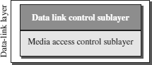

3. DLC SERVICES

The data link control (DLC) deals with procedures for communication between two adjacent nodes—node-to-node communication—no matter whether the link is dedicated or broadcast.
- Data link control service include
    - Framing (2) Flow Control (3) Error Control

FRAMING
- The data-link layer packs the bits of a message into frames, so that each frame is distinguishable from another.
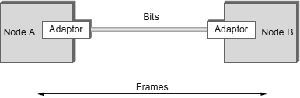
- Although the whole message could be packed in one frame, that is not normally done.
- One reason is that a frame can be very large, making flow and error control very inefficient.

- When a message is carried in one very large frame, even a single-bit error would require the retransmission of the whole frame.
- When a message is divided into smaller frames, a single-bit error affects only that small frame.
- Framing in the data-link layer separates a message from one source to a destination by adding a sender address and a destination address.
- The destination address defines where the packet is to go; the sender address helps the recipient acknowledge the receipt.

Frame Size
- Frames can be of fixed or variable size.
- Frames of fixed size are called cells. In fixed-size framing, there is no need for defining the boundaries of the frames; the size itself can be used as a delimiter.
- In variable-size framing, we need a way to define the end of one frame and the beginning of the next. Two approaches were used for this purpose: a character-oriented approach and a bit-oriented approach.

Character-Oriented Framing
- In character-oriented (or byte-oriented) framing, data to be carried are 8-bit characters.
- To separate one frame from the next, an 8-bit (1-byte) flag is added at the beginning and the end of a frame.
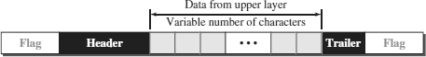
- The flag, composed of protocol-dependent special characters, signals the start or end of a frame.

- Any character used for the flag could also be part of the information.
- If this happens, when it encounters this pattern in the middle of the data,the receiver thinks it has reached the end of the frame.
- To fix this problem, a byte-stuffing strategy was added to character- oriented framing.

Byte Stuffing (or) Character Stuffing

Byte stuffing is the process of adding one extra byte whenever there is a flag or escape character in the text.
- In byte stuffing, a special byte is added to the data section of the frame when there is a character with the same pattern as the flag.
- The data section is stuffed with an extra byte. This byte is usually called the escape character (ESC) and has a predefined bit pattern.
- Whenever the receiver encounters the ESC character, it removes it from the data section and treats the next character as data, not as a delimiting flag.

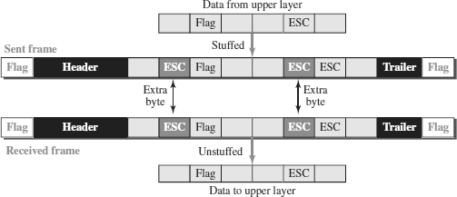

Bit-Oriented Framing
- In bit-oriented framing, the data section of a frame is a sequence of bits to be interpreted by the upper layer as text, graphic, audio, video, and so on.
- In addition to headers and trailers), we still need a delimiter to separate one frame from the other.
- Most protocols use a special 8-bit pattern flag, 01111110, as the delimiter to define the beginning and the end of the frame
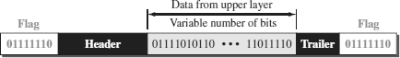

- If the flag pattern appears in the data, the receiver must be informed that this is not the end of the frame.
- This is done by stuffing 1 single bit (instead of 1 byte) to prevent the pattern from looking like a flag. The strategy is called bit stuffing.

Bit Stuffing

Bit stuffing is the process of adding one extra 0 whenever five consecutive 1s follow a 0 in the data, so that the receiver does not mistake the pattern 0111110 for a flag.
- In bit stuffing, if a 0 and five consecutive 1 bits are encountered, an extra 0 is added.
- This extra stuffed bit is eventually removed from the data by the receiver.
- The extra bit is added after one 0 followed by five 1’s regardless of the value of the next bit.
- This guarantees that the flag field sequence does not inadvertently appear in the frame.

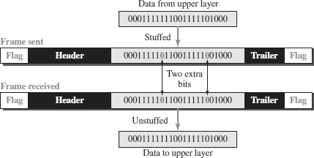

Frames are the units of digital transmission, particularly in computer networks and telecommunications. Frames are comparable to the packets of energy called photons in the case of light energy. Frame is continuously used in Time Division Multiplexing process.
Framing is a point-to-point connection between two computers or devices consisting of a wire in which data is transmitted as a stream of bits. However, these bits must be framed into discernible blocks of information. Framing is a function of the data link layer. It provides a way for a sender to transmit a set of bits that are meaningful to the receiver. Ethernet, token ring, frame relay, and other data link layer technologies have their own frame structures. Frames have headers that contain information such as error-checking codes.
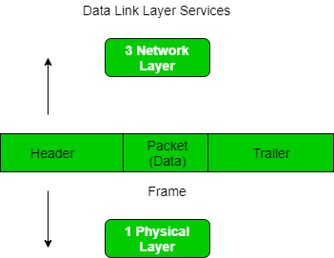
At the data link layer, it extracts the message from the sender and provides it to the receiver by providing the sender’s and receiver’s addresses. The advantage of using frames is that data is broken up into recoverable chunks that can easily be checked for corruption.
The process of dividing the data into frames and reassembling it is transparent to the user and is handled by the data link layer.
Framing is an important aspect of data link layer protocol design because it allows the transmission of data to be organized and controlled, ensuring that the data is delivered accurately and efficiently.

Problems in Framing
- Detecting start of the frame: When a frame is transmitted, every station must be able to detect it. Station detects frames by looking out for a special sequence of bits that marks the beginning of the frame i.e. SFD (Starting Frame Delimiter).
- How does the station detect a frame: Every station listens to link for SFD pattern through a sequential circuit. If SFD is detected, sequential circuit alerts station. Station checks destination address to accept or reject frame.
- Detecting end of frame: When to stop reading the frame.
- Handling errors: Framing errors may occur due to noise or other transmission errors, which can cause a station to misinterpret the frame. Therefore, error detection and correction mechanisms, such as cyclic redundancy check (CRC), are used to ensure the integrity of the frame.
- Framing overhead: Every frame has a header and a trailer that contains control information such as source and destination address, error detection code, and other protocol-related information. This overhead reduces the available bandwidth for data transmission, especially for small-sized frames.
- Framing incompatibility: Different networking devices and protocols may use different framing methods, which can lead to framing incompatibility issues. For example, if a device using one framing method sends data to a device using a different framing method, the receiving device may not be able to correctly interpret the frame.
- Framing synchronization: Stations must be synchronized with each other to avoid collisions and ensure reliable communication. Synchronization requires that all stations agree on the frame boundaries and timing, which can be challenging in complex networks with many devices and varying traffic loads.
- Framing efficiency: Framing should be designed to minimize the amount of data overhead while maximizing the available bandwidth for data transmission. Inefficient framing methods can lead to lower network performance and higher latency.

Types of framing
There are two types of framing:
1. Fixed-size: The frame is of fixed size and there is no need to provide boundaries to the frame, the length of the frame itself acts as a delimiter.
- Drawback: It suffers from internal fragmentation if the data size is less than the frame size
- Solution: Padding
2. Variable size: In this, there is a need to define the end of the frame as well as the beginning of the next frame to distinguish. This can be done in two ways:
- Length field – We can introduce a length field in the frame to indicate the length of the frame. Used in Ethernet(802.3). The problem with this is that sometimes the length field might get corrupted.
- End Delimiter (ED) – We can introduce an ED(pattern) to indicate the end of the frame. Used in Token Ring. The problem with this is that ED can occur in the data. This can be solved by:
1. Character/Byte Stuffing: Used when frames consist of characters. If data contains ED then, a byte is stuffed into data to differentiate it from ED.
Let ED = “$” –> if data contains ‘$’ anywhere, it can be escaped using ‘\O’ character.
–> if data contains ‘\O$’ then, use ‘\O\O\O$'($ is escaped using \O and \O is escaped using \O).
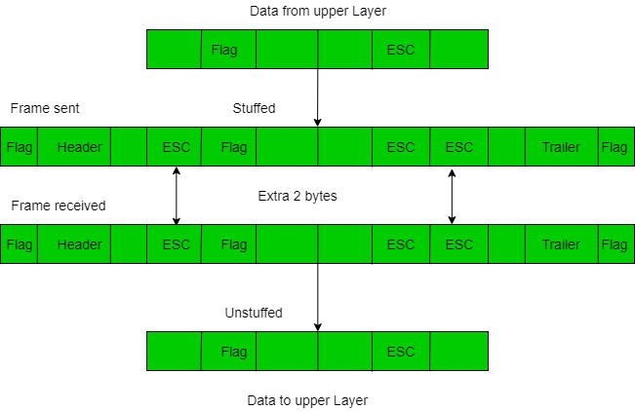
Disadvantage – It is very costly and obsolete method.
2. Bit Stuffing: Let ED = 01111 and if data = 01111
–> Sender stuffs a bit to break the pattern i.e. here appends a 0 in data = 011101.
–> Receiver receives the frame.
–> If data contains 011101, receiver removes the 0 and reads the data.
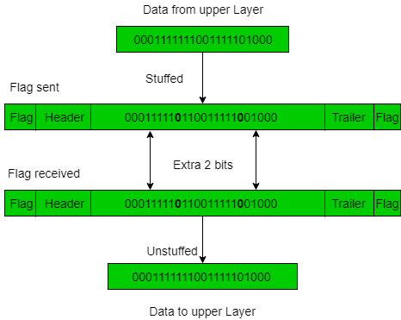
Examples:
- If Data –> 011100011110 and ED –> 0111 then, find data after bit stuffing.
--> 011010001101100
- If Data –> 110001001 and ED –> 1000 then, find data after bit stuffing?
--> 11001010011

framing in the Data Link Layer also presents some challenges, which include:
Variable frame length: The length of frames can vary depending on the data being transmitted, which can lead to inefficiencies in transmission. To address this issue, protocols such as HDLC and PPP use a flag sequence to mark the start and end of each frame.
Bit stuffing: Bit stuffing is a technique used to prevent data from being interpreted as control characters by inserting extra bits into the data stream. However, bit stuffing can lead to issues with synchronization and increase the overhead of the transmission.
Synchronization: Synchronization is critical for ensuring that data frames are transmitted and received correctly. However, synchronization can be challenging, particularly in high-speed networks where frames are transmitted rapidly.
Error detection: Data Link Layer protocols use various techniques to detect errors in the transmitted data, such as checksums and CRCs. However, these techniques are not foolproof and can miss some types of errors.
Efficiency: Efficient use of available bandwidth is critical for ensuring that data is transmitted quickly and reliably. However, the overhead associated with framing and error detection can reduce the overall efficiency of the transmission.

FLOW CONTROL

Flow control refers to a set of procedures used to restrict the amount of data that the sender can send before waiting for acknowledgment.
- The receiving device has limited speed and limited memory to store the data.
- Therefore, the receiving device must be able to inform the sending device to stop the transmission temporarily before the limits are reached.
- It requires a buffer, a block of memory for storing the information until they are processed.
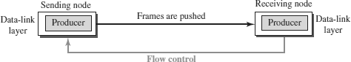

Two methods have been developed to control the flow of data:
- Stop-and-Wait
- Sliding Window
o

STOP-AND-WAIT
- The simplest scheme is the stop-and-wait algorithm.
- In the Stop-and-wait method, the sender waits for an acknowledgement after every frame it sends.
- When acknowledgement is received, then only next frame is sent.
- The process of alternately sending and waiting of a frame continues until the sender transmits the EOT (End of transmission) frame.

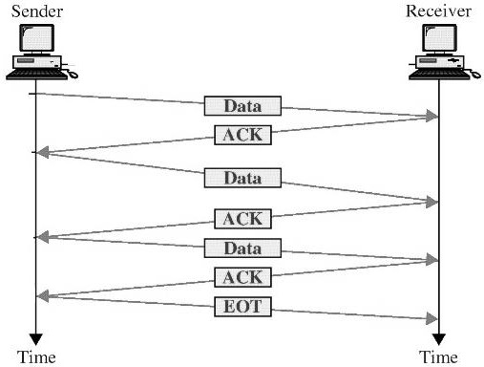

- If the acknowledgement is not received within the allotted time, then the sender assumes that the frame is lost during the transmission, so it will retransmit the frame.
- The acknowledgement may not arrive because of the following three scenarios :
- Original frame is lost
- ACK is lost
- ACK arrives after the timeout
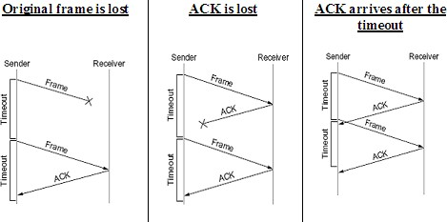

Advantage of Stop-and-wait
- The Stop-and-wait method is simple as each frame is checked and acknowledged before the next frame is sent

Disadvantages of Stop-And-Wait
- In stop-and-wait, at any point in time, there is only one frame that is sent and waiting to be acknowledged.
- This is not a good use of transmission medium.
- To improve efficiency, multiple frames should be in transition while waiting for ACK.

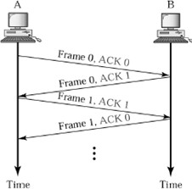
PIGGYBACKING
- A method to combine a data frame with ACK.
- Piggybacking saves bandwidth
- Station A and B both have data to send.
- Instead of sending separately, station A sends a data frame that includes an ACK.
- Station B does the same thing.

SLIDING WINDOW
- The Sliding Window is a method of flow control in which a sender can transmit the several frames before getting an acknowledgement.
- In Sliding Window Control, multiple frames can be sent one after the another due to which capacity of the communication channel can be utilized efficiently.
- A single ACK acknowledge multiple frames.
- Sliding Window refers to imaginary boxes at both the sender and receiver end.
- The window can hold the frames at either end, and it provides the upper limit on the number of frames that can be transmitted before the acknowledgement.
- Frames can be acknowledged even when the window is not completely filled.
- The window has a specific size in which they are numbered as modulo-n means that they are numbered from 0 to n-1.
- For example, if n = 8, the frames are numbered from
0,1,2,3,4,5,6,7,0,1,2,3,4,5,6,7,0,1........
- The size of the window is represented as n-1. Therefore, maximum n-1 frames can be sent before acknowledgement.
- When the receiver sends the ACK, it includes the number of the next frame that it wants to receive.
- For example, to acknowledge the string of frames ending with frame number 4, the receiver will send the ACK containing the number 5.
- When the sender sees the ACK with the number 5, it got to know that the frames from 0 through 4 have been received.

Sender Window | Receiver Window
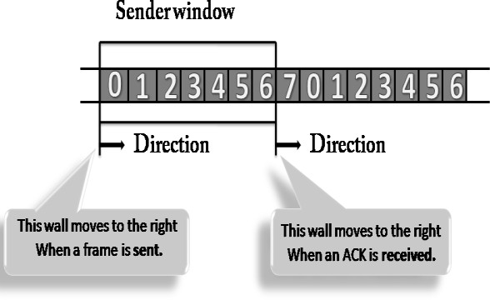 | 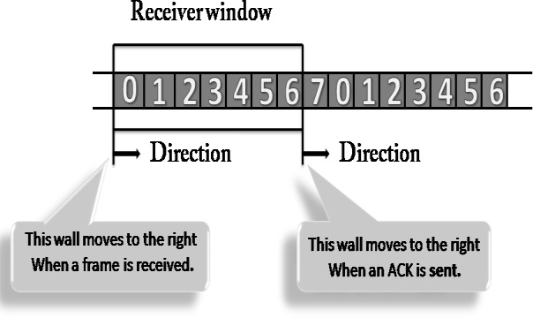
- At the beginning of a transmission, the sender window contains n-1 frames.  - When a frame is sent, the size of the window shrinks.  - For example, if the size of the window is ‘w’ and if three frames are sent out, then the number of frames left out in the sender window is w-3.  - Once the ACK has arrived, then the sender window expands to the number which will be equal to the number of frames acknowledged by ACK. | - At the beginning of transmission, the receiver window does not contain n frames, but it contains n-1 spaces for frames.  - When the new frame arrives, the size of the window shrinks.  - For example, the size of the window is w and if three frames are received then the number of spaces available in the window is (w-3).  - Once the acknowledgement is sent, the receiver window expands by the number equal to the number of frames acknowledged.

Example of Sliding Window
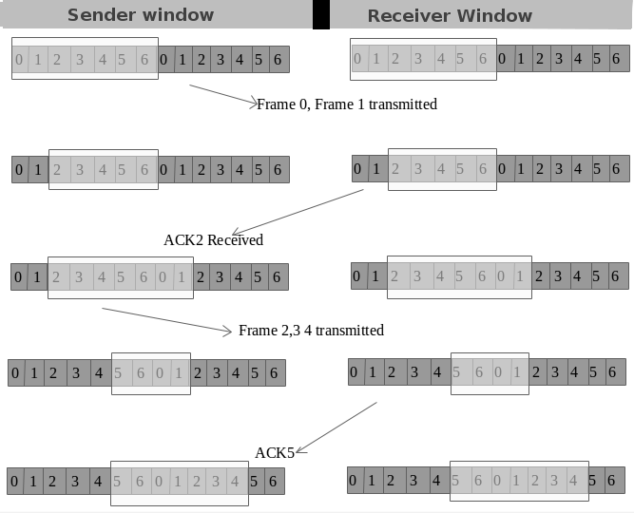

3. ERROR CONTROL

Data can be corrupted during transmission. For reliable communication, errors must be detected and corrected. Error Control is a technique of error detection and retransmission.

TYPES OF ERRORS
SINGLE-BIT ERROR
The term Single-bit error means that only one bit of a given data unit (such as byte, character, data unit or packet) is changed from 1 to 0 or from 0 to 1.
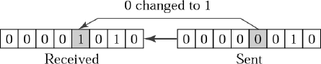

BURST ERROR
The term Burst Error means that two or more bits in the data unit have changed from 1 to 0 or from 0 to 1.

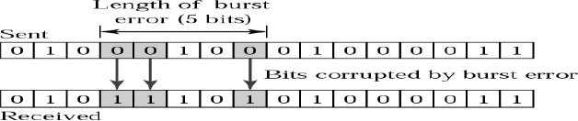

ERROR DETECTION TECHNIQUES / METHODS
The basic idea behind any error detection scheme is to add additional information to a frame that can be used to determine if errors have been introduced.
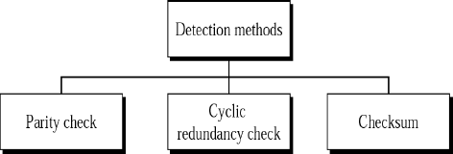

PARITY CHECK
- One bit, called parity bit is added to every data unit so that the total number of 1’s in the data unit becomes even (or) odd.
- The source then transmits this data via a link, and bits are checked and verified at the destination.
- Data is considered accurate if the number of bits (even or odd) matches the number transmitted from the source.
- This techniques is the most common and least complex method.

- Even parity – Maintain even number of 1s E.g., 1011 → 1011 1
- Odd parity – Maintain odd number of 1s E.g., 1011 → 1011 0

CYCLIC REDUNDANCY CHECK
- Cyclic codes refers to encoding messages by adding a fixed-length check value.
- CRCs are popular because they are simple to implement, easy to analyze mathematically and particularly good at detecting common errors caused in transmission channels.

Steps Involved :
- Consider the original message (dataword) as M(x) consisting of ‘k’ bits and the divisor as C(x) consists of ‘n+1’ bits.
- The original message M(x) is appended by ‘n’ bits of zero’s. Let us call this zero-extended message as T(x).
- Divide T(x) by C(x) and find the remainder.
- The division operation is performed using XOR operation.
- The resultant remainder is appended to the original message M(x) as CRC and sent by the sender(codeword).
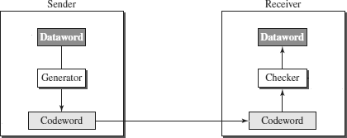

Example 1:
- Consider the Dataword / Message M(x) = 1001
- Divisor C(x) = 1011 (n+1=4)
- Appending ‘n’ zeros to the original Message M(x).
- The resultant messages is called T(x) = 1001 000. (here n=3)
- Divide T(x) by the divisor C(x) using XOR operation.

ERROR CONTROL

- Error control includes both error detection and error correction.
- Whenever an error is detected, specified frames are retransmitted
- It allows the receiver to inform the sender if a frame is lost or damaged during transmission and coordinates the retransmission of those frames by the sender.
- Includes the following actions:

Error detection
  - Positive Acknowledgement (ACK): if the frame arrived with no errors
  - Negative Acknowledgement (NAK): if the frame arrived with errors
  - Retransmissions after Timeout: Frame is retransmitted after certain amount of time if no acknowledgement was received
- Error control in the data link layer is based on automatic repeat request (ARQ).

Categories of Error Control
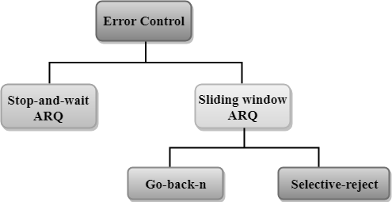

STOP-AND-WAIT ARQ
- Stop-and-wait ARQ is a technique used to retransmit the data in case of damaged or lost frames.
- This technique works on the principle that the sender will not transmit the next frame until it receives the acknowledgement of the last transmitted frame.

Two possibilities of the retransmission in Stop and Wait ARQ:

- Damaged Frame: When the receiver receives a damaged frame(i.e., the frame contains an error), then it returns the NAK frame. For example, when the frame DATA 1 is sent, and then the receiver sends the ACK 0 frame means that the data 1 has arrived correctly. The sender transmits the next frame: DATA 0. It reaches undamaged, and the receiver returns ACK 1. The sender transmits the third frame: DATA 1. The receiver reports an error and returns the NAK frame. The sender retransmits the DATA 1 frame.
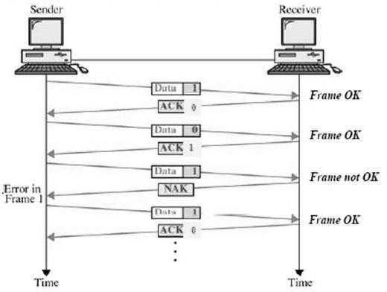

- Lost Frame: Sender is equipped with the timer and starts when the frame is transmitted. Sometimes the frame has not arrived at the receiving end so that it cannot be acknowledged either positively or negatively. The sender waits for acknowledgement until the timer goes off. If the timer goes off, it retransmits the last transmitted frame.
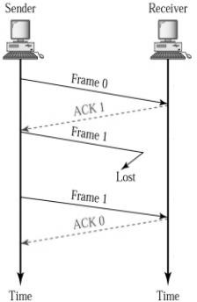

SLIDING WINDOW ARQ

Sliding Window ARQ is a technique used for continuous transmission error control.

Two protocols used in sliding window ARQ:

- GO-BACK-N ARQ
  - In Go-Back-N ARQ protocol, if one frame is lost or damaged, then it retransmits all the frames after which it does not receive the positive ACK.
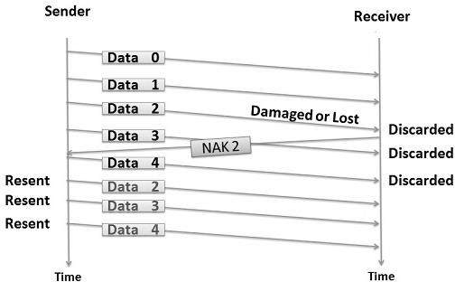
  - In the above figure, three frames (Data 0,1,2) have been transmitted before an error discovered in the third frame.
  - The receiver discovers the error in Data 2 frame, so it returns the NAK 2 frame.
  - All the frames including the damaged frame (Data 2,3,4) are discarded as it is transmitted after the damaged frame.
  - Therefore, the sender retransmits the frames (Data2,3,4).

- SELECTIVE-REJECT(REPEAT) ARQ

  - Selective-Reject ARQ technique is more efficient than Go-Back-n ARQ.
  - In this technique, only those frames are retransmitted for which negative acknowledgement (NAK) has been received.
  - The receiver storage buffer keeps all the damaged frames on hold until the frame in error is correctly received.
  - The receiver must have an appropriate logic for reinserting the frames in a correct order.
  - The sender must consist of a searching mechanism that selects only the requested frame for retransmission.

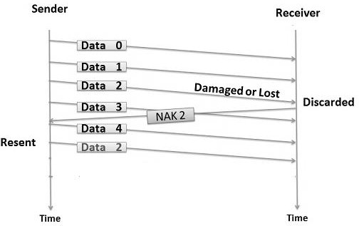

  - In the above figure, three frames (Data 0,1,2) have been transmitted before an error discovered in the third frame.
  - The receiver discovers the error in Data 2 frame, so it returns the NAK 2 frame.
  - The damaged frame only (Data 2) is discarded.
  - The other subsequent frames (Data 3,4) are accepted.
  - Therefore, the sender retransmits only the damaged frame (Data2).
4. DATA-LINK LAYER PROTOCOLS

Four protocols have been defined for the data-link layer controls. They are
- Simple Protocol
- Stop-and-Wait Protocol
- Go-Back-N Protocol
- Selective-Repeat Protocol

SIMPLE PROTOCOL

  - The first protocol is a simple protocol with neither flow nor error control.
  - We assume that the receiver can immediately handle any frame it receives.
  - In other words, the receiver can never be overwhelmed with incoming frames.
  - The data-link layers of the sender and receiver provide transmission services for their network layers.

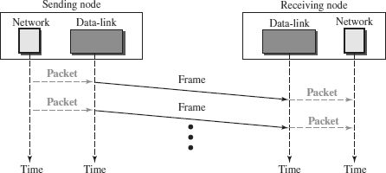
  - The data-link layer at the sender gets a packet from its network layer, makes a frame out of it, and sends the frame.
  - The data-link layer at the receiver receives a frame from the link, extracts the packet from the frame, and delivers the packet to its network layer.

NOTE :

- STOP-AND-WAIT PROTOCOL
REFER STOP AND WAIT FROM FLOW CONTROL

- GO-BACK-N PROTOCOL
REFER GO-BACK-N ARQ FROM ERROR CONTROL

- SELECTIVE-REPEAT PROTOCOL
REFER SELECTIVE-REPEAT ARQ FROM ERROR CONTROL
5. HDLC (HIGH-LEVEL DATA LINK CONTROL)

BIT ORIENTED PROTOCOL:
Bit stuffing is the process of adding one extra 0 whenever five consecutive is follow a 0 in the data so that the receiver does not mistake the pattern 0111110 for a flag. In this, the data section of a frame is a sequence of bits to be interpreted by the upper layer as text, audio, video, and audio, etc. Where in addition to the header, the designer will require a delimiter to separate one frame from other frames. Well, most protocols use a special 8-bit pattern flag as the delimiter to determine the starting and end of the frame.
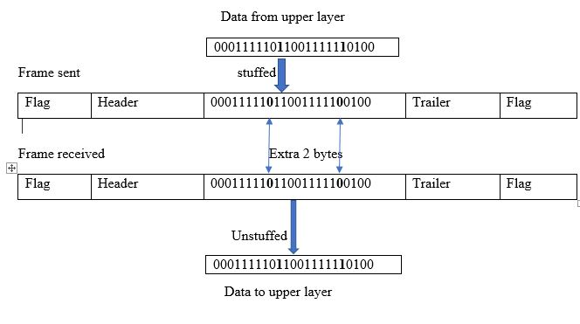
  - High-level Data Link Control (HDLC) is a bit-oriented protocol
  - HDLC is used for communication over point-to-point and multipoint links.
  - HDLC implements the Stop-and-Wait protocol.

HDLC CONFIGURATIONS AND TRANSFER MODES
HDLC provides two common transfer modes that can be used in different configurations:
- Normal response mode (NRM)
- Asynchronous balanced mode (ABM).

Normal response mode (NRM)
  - In normal response mode (NRM), the station configuration is unbalanced.
  - We have one primary station and multiple secondary stations.
  - A primary station can send commands; a secondary station can only respond.
  - The NRM is used for both point-to-point and multipoint links.
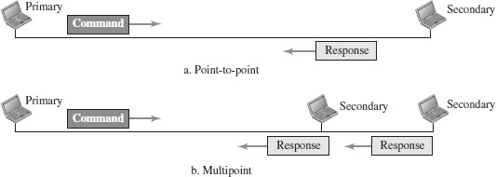

Asynchronous balanced mode (ABM)
  - In ABM, the configuration is balanced.
  - The link is point-to-point, and each station can function as a primary and a secondary (acting as peers).
  - This is the common mode today.
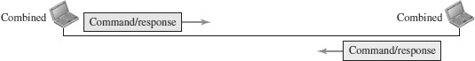

HDLC FRAMES
HDLC defines three types of frames:
- Information frames (I-frames) - used to carry user data
- Supervisory frames (S-frames) - used to carry control information
- Unnumbered frames (U-frames) – reserved for system management

Each type of frame serves as an envelope for the transmission of a different type of message.
Each frame in HDLC may contain up to six fields:
- Beginning flag field
- Address field
- Control field
- Information field (User Information/ Management Information)
- Frame check sequence (FCS) field
- Ending flag field

In multiple-frame transmissions, the ending flag of one frame can serve as the beginning flag of the next frame.

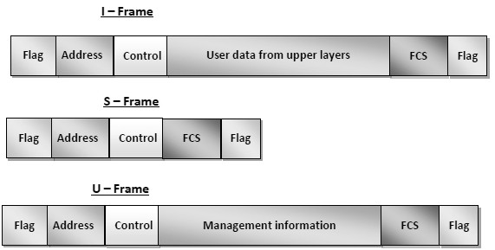

  - Flag field - This field contains synchronization pattern 01111110, which identifies both the beginning and the end of a frame.
  - Address field - This field contains the address of the secondary station. If a primary station created the frame, it contains a ‘to’ address. If a secondary station creates the frame, it contains a ‘from’ address. The address field can be one byte or several bytes long, depending on the needs of the network.
  - Control field. The control field is one or two bytes used for flow and error control.
  - Information field. The information field contains the user’s data from the network layer or management information. Its length can vary from one network to another.
  - FCS field. The frame check sequence (FCS) is the HDLC error detection field. It can contain either a 16- bit or 32-bit CRC.

CONTROL FIELD FORMAT FOR THE DIFFERENT FRAME TYPES

Control Field for I-Frames
  - I-frames are designed to carry user data from the network layer. In addition, they can include flow-control and error-control information
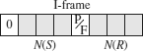
  - The first bit defines the type. If the first bit of the control field is 0, this means the frame is an I-frame.
  - The next 3 bits, called N(S), define the sequence number of the frame.
  - The last 3 bits, called N(R), correspond to the acknowledgment number when piggybacking is used.
  - The single bit between N(S) and N(R) is called the P/F bit. If this bit is 1 it means poll (the frame is sent by a primary station to a secondary).

  - If this bit is 0 it means final(the frame is sent by a secondary to a Primary).

Control Field for S-Frames
  - Supervisory frames are used for flow and error control whenever piggybacking is either impossible or inappropriate.
  - S-frames do not have information fields
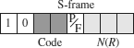

  - If the first 2 bits of the control field are 10, this means the frame is an S- frame.
  - The last 3 bits, called N(R),correspond to the acknowledgment number (ACK) or negative acknowledgment number (NAK), depending on the type of S-frame.
  - The 2 bits called code are used to define the type of S-frame itself.
  - With 2 bits, we can have four types of S-frames –

Receive ready (RR), Receive not ready (RNR), Reject (REJ) and Selective reject (SREJ).

Control Field for U-Frames
  - Unnumbered frames are used to exchange session management and control information between connected devices.
  - U-frames contain an information field, but used only for system management information and not user data.
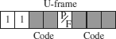

  - If the first 2 bits of the control field are 11, this means the frame is an U- frame.
  - U-frame codes are divided into two sections: a 2-bit prefix before the P/F bit and a 3-bit suffix after the P/F bit.
  - Together, these two segments (5 bits) can be used to create up to 32 different types of U-frames.

6. POINT-TO-POINT PROTOCOL (PPP)

  - Point-to-Point Protocol (PPP) was devised by IETF (Internet Engineering Task Force) in 1990 as a Serial Line Internet Protocol (SLIP).
  - PPP is a data link layer communications protocol used to establish a direct connection between two nodes.
  - It connects two routers directly without any host or any other networking device in between.
  - It is used to connect the Home PC to the server of ISP via a modem.
  - It is a byte - oriented protocol that is widely used in broadband communications having heavy loads and high speeds.
  - Since it is a data link layer protocol, data is transmitted in frames. It is also known as RFC 1661.

Services Provided by PPP
The main services provided by Point - to - Point Protocol are −
- Defining the frame format of the data to be transmitted.
- Defining the procedure of establishing link between two points and exchange of data.
- Stating the method of encapsulation of network layer data in the frame.
- Stating authentication rules of the communicating devices.
- Providing address for network communication.
- Providing connections over multiple links.
- Supporting a variety of network layer protocols by providing a range os services.

PPP Frame
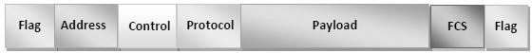
PPP is a byte - oriented protocol where each field of the frame is composed of one or more bytes.

- Flag − 1 byte that marks the beginning and the end of the frame. The bit pattern of the flag is 01111110.
- Address − 1 byte which is set to 11111111 in case of broadcast.
- Control − 1 byte set to a constant value of 11000000.
- Protocol − 1 or 2 bytes that define the type of data contained in the payload field.
- Payload − This carries the data from the network layer. The maximum length of the payload field is 1500 bytes.
- FCS − It is a 2 byte(16-bit) or 4 bytes(32-bit) frame check sequence for error detection. The standard code used is CRC.

Byte Stuffing in PPP Frame
Byte stuffing is used is PPP payload field whenever the flag sequence appears in the message, so that the receiver does not consider it as the end of the frame. The escape byte, 01111101, is stuffed before every byte that contains the same byte as the flag byte or the escape byte. The receiver on receiving the message removes the escape byte before passing it onto the network layer.

Transition Phases in PPP
The PPP connection goes through different states as shown in a transition phase
diagram.
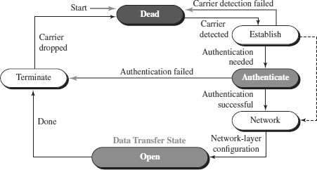
- Dead: In dead phase the link is not used. There is no active carrier and the line is quiet.
- Establish: Connection goes into this phase when one of the nodes start communication. In this phase, two parties negotiate the options. If negotiation is successful, the system goes into authentication phase or directly to networking phase.
- Authenticate: This phase is optional. The two nodes may decide whether they need this phase during the establishment phase. If they decide to proceed with authentication, they send several authentication packets. If the result is successful, the connection goes to the networking phase; otherwise, it goes to the termination phase.
- Network: In network phase, negotiation for the network layer protocols takes place.PPP specifies that two nodes establish a network layer agreement before data at the network layer can be exchanged. This is because PPP supports several protocols at network layer. If a node is running multiple protocols simultaneously at the network layer, the receiving node needs to know which protocol will receive the data.
- Open: In this phase, data transfer takes place. The connection remains in this phase until one of the endpoints wants to end the connection.
- Terminate: In this phase connection is terminated.

Components/Protocols of PPP
Three sets of components/protocols are defined to make PPP powerful:
- Link Control Protocol (LCP)
- Authentication Protocols (AP)
- Network Control Protocols (NCP)

Link Control Protocol (LCP) − It is responsible for establishing, configuring, testing, maintaining and terminating links for transmission. It also provides negotiation mechanisms to set options between the two endpoints. Both endpoints of the link must reach an agreement about the options before the link can be established.

Authentication Protocols (AP) − Authentication means validating the identity of a user who needs to access a set of resources. PPP has created two protocols for authentication -Password Authentication Protocol and Challenge Handshake Authentication Protocol.

PAP
The Password Authentication Protocol (PAP) is a simple authentication procedure with a two-step process:
  - The user who wants to access a system sends an authentication identification (usually the user name) and a password.
  - The system checks the validity of the identification and password and either accepts or denies connection.

CHAP
The Challenge Handshake Authentication Protocol (CHAP) is a three-way handshaking authentication protocol that provides greater security than PAP. In this method, the password is kept secret; it is never sent online.
- The system sends the user a challenge packet containing a challenge value.
- The user applies a predefined function that takes the challenge value and the user’s own password and creates a result. The user sends the result in the response packet to the system.
- The system does the same. It applies the same function to the password of the user (known to the system) and the challenge value to create a result. If the result created is the same as the result sent in the response packet, access is granted; otherwise, it is denied.

CHAP is more secure than PAP, especially if the system continuously changes the challenge value. Even if the intruder learns the challenge value and the result, the password is still secret.

Network Control Protocols (NCP) − PPP is a multiple-network-layer protocol. It can carry a network-layer data packet from protocols defined by the Internet. PPP

has defined a specific Network Control Protocol for each network protocol. These protocols are used for negotiating the parameters and facilities for the network layer. For every higher-layer protocol supported by PPP, one NCP is there.
7. MEDIA ACCESS CONTROL (MAC)

- When two or more nodes transmit data at the same time, their frames will collide and the link bandwidth is wasted during collision.
- To coordinate the access of multiple sending/receiving nodes to the shared link, we need a protocol to coordinate the transmission.
- These protocols are called Medium or Multiple Access Control (MAC) Protocols. MAC belongs to the data link layer of OSI model
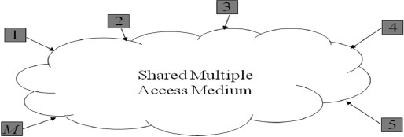
- MAC defines rules for orderly access to the shared medium. It tries to ensure that no two nodes are interfering with each other’s transmissions, and deals with the situation when they do.

Issues involved in MAC
The key issues involved are –
  - Where the control is exercised - refers to whether the control is exercised in a centralized or distributed manner
  - How the control is exercised - refers to in what manner the control is exercised

Goals of MAC
- Fairness in sharing
- Efficient sharing of bandwidth
- Need to avoid packet collisions at the receiver due to interference

MAC Management
  - Medium allocation (collision avoidance)
  - Contention resolution (collision handling)

MAC Types
- Round-Robin : – Each station is given opportunity to transmit in turns. Either a central controller polls a station to permit to go, or stations can coordinate among themselves.
- Reservation : - Station wishing to transmit makes reservations for time slots in advance. (Centralized or distributed).
- Contention (Random Access) : - No control on who tries; If collision‖ occurs, retransmission takes place.

MECHANISMS USED
  - Wired Networks :
    - CSMA / CD – Carrier Sense Multiple Access / Collision Detection
  - Wireless Networks :
    - CSMA / CA – Carrier Sense Multiple Access / Collision Avoidance

CARRIER SENSE MULTIPLE ACCESS / COLLISION DETECTION (CSMA / CD)

- Carrier Sense in CSMA/CD means that all the nodes sense the medium to check whether it is idle or busy.
  - If the carrier sensed is idle, then the node transmits the entire frame.
  - If the carrier sensed is busy, the transmission is postponed.

- Collision Detect means that a node listens as it transmits and can therefore detect when a frame it is transmitting has collided with a frame transmitted by another node.

Flowchart of CSMA/CD Operation

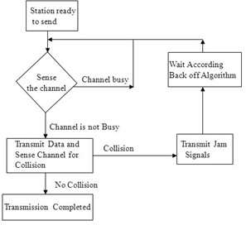

Transmitter Algorithm in CSMA/CD
- Transmitter Algorithm defines the procedures for a node that senses a busy medium.
- Three types of Transmitter Algorithm exist.
- They are
- Non-Persistent Strategy
- Persistent Strategy : 1-Persistent & P-Persistent

Non-Persistent Strategy
- In the non-persistent method, a station that has a frame to send senses the line.
- If the line is idle, it sends immediately.
- If the line is not idle, it waits a random amount of time and then senses the line again.

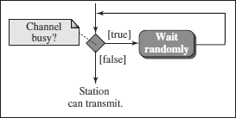

- The non-persistent approach reduces the chance of collision because it is unlikely that two or more stations will wait the same amount of time and retry to send simultaneously.
- However, this method reduces the efficiency of the network because the medium remains idle when there may be stations with frames to send.

Persistent Strategy

Persistent :
  - The 1-persistent method is simple and straightforward.
  - In this method, after the station finds the line idle, it sends its frame immediately (with probability 1).
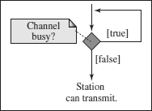
  - This method has the highest chance of collision because two or more stations may find the line idle and send their frames immediately.

P-Persistent :
  - In this method, after the station finds the line idle it follows these steps:
  - With probability p, the station sends its frame.
  - With probability q = 1 − p, the station waits for the beginning of the next time slot and checks the line again.
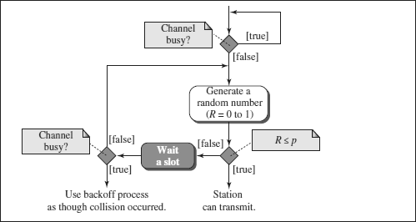

  - The p-persistent method is used if the channel has time slots with a slot duration equal to or greater than the maximum propagation time.
  - The p-persistent approach combines the advantages of the other two strategies. It reduces the chance of collision and improves efficiency.
.

EXPONENTIAL BACK-OFF
  - Once an adaptor has detected a collision and stopped its transmission, it waits a certain amount of time and tries again.
  - Each time it tries to transmit but fails, the adaptor doubles the amount of time it waits before trying again.
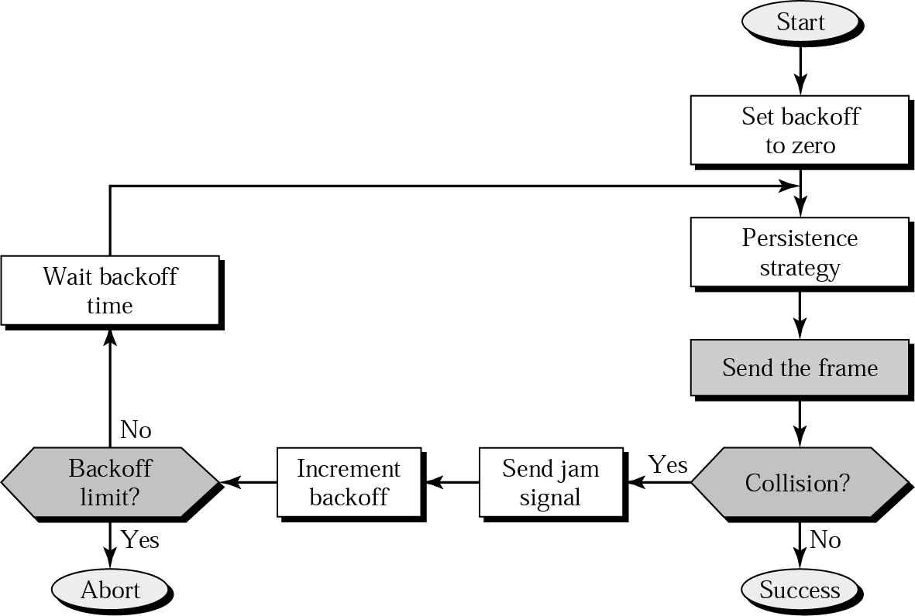
  - This strategy of doubling the delay interval between each retransmission attempt is a general technique known as exponential back-off.

CARRIER SENSE MULTIPLE ACCESS / COLLISION AVOIDANCE (CSMA/CA)
  - Carrier sense multiple access with collision avoidance (CSMA/CA) was invented for wireless networks.
  - Wireless protocol would follow exactly the same algorithm as the Ethernet—Wait until the link becomes idle before transmitting and back off should a collision occur.
  - Collisions are avoided through the use of CSMA/CA’s three strategies: the interframe space, the contention window, and acknowledgments

Interframe Space (IFS) - First, collisions are avoided by deferring transmission even if the channel is found idle. When an idle channel is found, the station does not send immediately. It waits for a period of time called the interframe space or IFS.

Contention Window - The contention window is an amount of time divided into slots. A station that is ready to send chooses a random number of slots as its wait time. The number of slots in the window changes according to the binary exponential backoff strategy. This means that it is set to one slot the first time and then doubles each time the station cannot detect an idle channel after the IFS time.

Acknowledgment - In addition, the data may be corrupted during the transmission.The positive acknowledgment and the time-out timer can help guarantee that the receiver has received the frame.

Performance of Carrier sense multiple access with collision detection (CSMA/CD):
The CSMA method does not tell us what to do in case there is a collision. Carrier sense multiple access with collision detection (CSMA/CD) adds to the CSMA algorithm to deal with the collision. In CSMA/CD, the size of a frame must be large enough so that collision can be detected by the sender while sending the frame. So, the frame transmission delay must be at least two times the maximum propagation delay. Assume some station transmitted data packet and successfully get to the destination but it is just the Best Case, so we have to take the Worst Case scenario in which there will be contention slots. Contention slots are those slots that are not able to transmit their journey due to the collision. Suppose station A transmitted data but collide and the worst-case time wasted is 2Tp and then some station B found out a way to transmit the data so it took (As shown in Figure)
Tp ( propagation delay) + Tt(transmission time)
Now we don’t know how many contention slots, so we consider the worst-case to be of n contention slots.
Efficiency = Tt / ( C*2*Tp + Tt + Tp)
Tt - transmission time
Tp - propagation time
C - number of collision
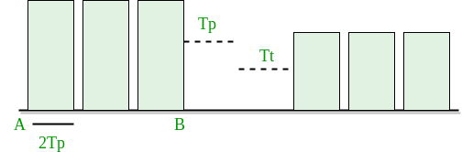
In CSMA/CD, for success, only 1 station should transmit while others shouldn’t. Let p be the probability to transmit data successfully.
P(success) = nC1 * p * (1-p)^{n-1} (by using Binomial distribution)
For max P(success), differentiate with respect to p and equate to zero (to get maxima and minima).
We get P(max) = 1/e
Number of times we need to try before getting 1st success
1/P(MAX) = 1/(1/e) = e
Here number of times we need to try (C) = e. Put a = Tt/Tp and divide by T in Efficiency = Tt / (C* 2 * Tp + Tt + Tp) We get,
Efficiency = 1/(e*2a + 1 + a)
a = Tp/Tt
e = 2.72

Now
Efficiency = 1/( 1 + 6.44a)
Further Analysis of Efficiency :
Efficiency = 1/ (1 + 6.44a)

= 1/ {1 + 6.44(Tp/Tt)}

= 1/ {1 + 6.44((distance/speed)/(packet length/Bandwidth))}

= 1/ {1+ 6.44 ((distance * bandwidth)/ (speed*packet length))}
From this derivation, we can conclude many relations :
- If distance increases, the efficiency of CSMA decreases.
- CSMA is not suitable for long-distance networks like WAN but works optimally for LAN.
- If the length of the packet is bigger, the efficiency of CSMA also increases; but the maximum limit for length is 1500 Bytes.
- Transmission Time >= 2*Propagation Time
9. WIRELESS LAN ( IEEE 802.11)

- Wireless communication is one of the fastest-growing technologies.
- The demand for connecting devices without the use of cables is increasing everywhere.
- Wireless LANs can be found on college campuses, in office buildings, and in many public areas.

ADVANTAGES OF WLAN / 802.11
- Flexibility: Within radio coverage, nodes can access each other as radio waves can penetrate even partition walls.
- Planning : No prior planning is required for connectivity as long as devices follow standard convention
- Design : Allows to design and develop mobile devices.
- Robustness : Wireless network can survive disaster. If the devices survive, communication can still be established.

DISADVANTAGES OF WLAN / 802.11
- Quality of Service : Low bandwidth (1 – 10 Mbps), higher error rates due to interference, delay due to error correction and detection.
- Cost : Wireless LAN adapters are costly compared to wired adapters.
- Proprietary Solution : Due to slow standardization process, many solution are proprietary that limit the homogeneity of operation.
- Restriction : Individual countries have their own radio spectral policies. This restricts the development of the technology
- Safety and Security : Wireless Radio waves may interfere with other devices. Eg; In a hospital, radio waves may interfere with high-tech equipment.

TECHNOLOGY USED IN WLAN / 802.11
  - WLAN’s uses Spread Spectrum (SS) technology.
  - The idea behind Spread spectrum technique is to spread the signal over a wider frequency band than normal, so as to minimize the impact of interference from other devices.
  - There are two types of Spread Spectrum:
    - Frequency Hopping Spread Spectrum (FHSS)
    - Direct Sequence Spread Spectrum (DSSS)

Frequency Hopping Spread Spectrum (FHSS)
- Frequency hopping is a spread spectrum technique that involves transmitting the signal over a random sequence of frequencies.
- That is, first transmitting at one frequency, then a second, then a third, and so on.
- The random sequence of frequencies is computed by a pseudorandom number generator.
- The receiver uses the same algorithm as the sender and initializes it with the same seed and hence is able to hop frequencies in sync with the transmitter to correctly receive the frame.

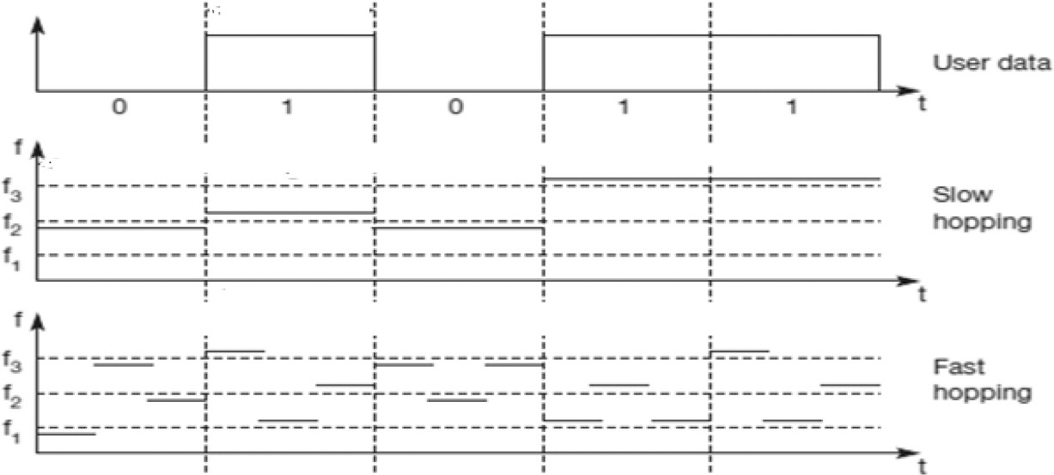

Direct Sequence Spread Spectrum (DSSS)
- Each bit of data is represented by multiple bits in the transmitted signal.
- DSSS takes a user data stream and performs an XOR operation with a pseudo –random number.
- This pseudo random number is called as chipping sequence.

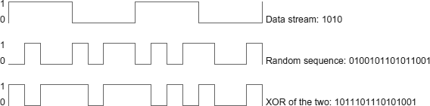

TOPOLOGY IN WLAN / 802.11
WLANs can be built with either of the following two topologies /architecture:
- Infra-Structure Network Topology
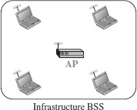
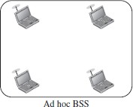
- Ad Hoc Network Topology
- An adhoc network is the architecture that is used to support mutual communication between wireless clients.
- Typically, an ad- hoc network is created spontaneously and does not support access to wired networks.
- An adhoc network does not require an AP.
Ad-Hoc Topology
(Peer-to-Peer Topology)
- An infrastructure network is the network architecture for providing communication between wireless clients and wired network resources.
- The transition of data from the wireless to wired medium occurs via a Base Station called AP(Access Point).
- An AP and its associated wireless clients define the coverage area.
Infra-Structure Topology
(AP based Topology)

ARCHITECURE OF WLAN / 802.11

Terminologies of IEEE 802.11 Architecture

Station: Stations (STA) comprise all devices and equipment that are connected to the wireless LAN. It can be of two types:
- Wireless Access Point (WAP): WAPs or simply access points (AP) are wireless routers that bridge connections for base stations.
- Client: Examples include computers, laptops, printers, and smartphones.
Access Point: It is a device that can be classified as a station because of its functionalities and acts as a connection between wireless medium and distributed systems.
Distribution System: A system used to interconnect a set of BSSs and integrated LANs to create an ESS.
Frame: It is a MAC protocol data unit.
SSID (Service Set Identifier): It’s the network name for a particular WLAN. All-access points and devices on a specific WLAN must use the same SSID to communicate.
SDU: It is a data unit that acts as an input to each layer. These can be fragmented or aggregated to form a PDU.
PDU: It is a data unit projected as an output to communicate with the corresponding layer at the other end. They contain a header specific to the layer.
Network Interface Controller: It is also known as network interface card. It is a hardware component that connects devices to the network.
Portal: Serves as a gateway to other networks

IEEE 802.11 Architecture and Services
In the year 1990, IEEE 802.11 Committee formed a new working group, the IEEE 802.11 standard which defines protocols for Wireless Local Area Networks (WLANs). Just like how Ethernet provides services for wired media, IEEE 802.11 architecture is designed to provide features for wireless networks.
An AP supports both wired and wireless connections. The 802.11 standard calls the upstream wired network the distribution system (DS). The AP bridges the wireless and wired L2 Ethernet frames, allowing traffic to flow from the wired to the wireless network and vice versa. Each wireless network has a unique SSID.
The 802.11 architecture provides some basic services for WLANs whose implementation is supported by MAC layer:

Basic Service Set
The Basic Service Set configuration consists of a group of stations and relies on an Access Point (AP), which serves as a logical hub. Stations from different BSSs interact through the AP, which functions as a bridge, linking multiple WLAN cells or channels.

Operating Modes
Depending upon the mode of operation, BSS can be categorized into the following types:
- Infrastructure BSS: Communication between stations takes place through access points. The AP and its associated wireless clients define the coverage area and form the BSS.
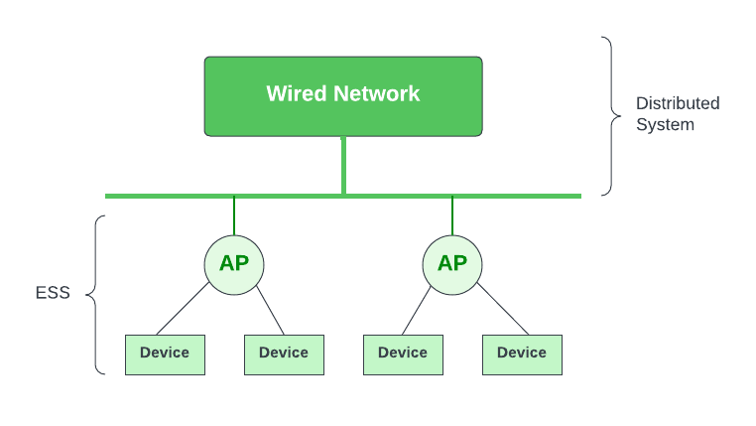
Infrastructure BSS
- Independent BSS – Supports mutual communication between wireless clients. An ad-hoc network is spontaneously created and does not support access to wired networks.
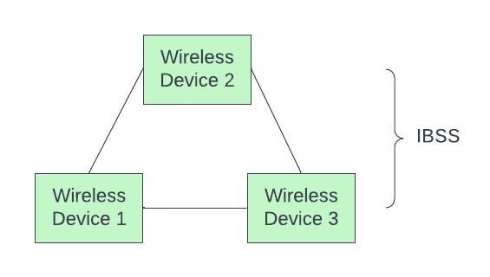
Independent BSS

- The standard defines two kinds of services: the Basic Service Set (BSS) and the Extended Service Set (ESS).

Basic Service Set (BSS)
- IEEE 802.11 defines the basic service set (BSS) as the building blocks of a wireless LAN.
- A basic service set is made of stationary or mobile wireless stations and an optional central base station, known as the access point (AP).
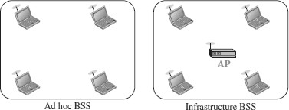

Extended Service Set (ESS)
- An extended service set (ESS) is made up of two or more BSSs with APs.
- In this case, the BSSs are connected through a distribution system, which is a wired or a wireless network.
- The distribution system connects the APs in the BSSs. The extended service set uses two types of stations: mobile and stationary.
- The mobile stations are normal stations inside a BSS.
- The stationary stations are AP stations that are part of a wired LAN.
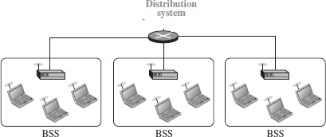

Station Types
IEEE 802.11 defines three types of stations based on their mobility in a wireless LAN:
- No-transition - A station with no-transition mobility is either stationary (not moving) or moving only inside a BSS.
- BSS-transition - A station with BSS-transition mobility can move from one BSS to another, but the movement is confined inside one ESS
ESS-transition - A station with ESS-transition mobility can move from one ESS to another.

COLLISION AVOIDANCE IN WLAN / 802.11

Wireless protocol would follow exactly the same algorithm as the Ethernet—Wait until the link becomes idle before transmitting and back off should a collision occur.

Hidden Node Problem

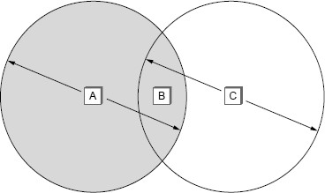

  - Consider the situation shown in the Figure.
  - Here A and C are both within range of B but not with each other.
  - Suppose both A and C want to communicate with B and so they each send a frame to B.
  - A and C are unaware of each other since their signals do not carry that far.
  - These two frames collide with each other at B, but neither A nor C is aware of this collision.
  - A and C are said to be hidden nodes with respect to each other.

Exposed Node Problem

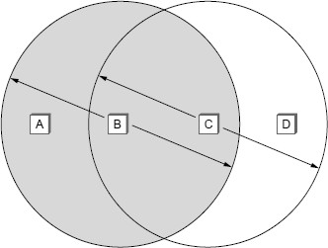

  - Each of the four nodes is able to send and receive signals that reach just the nodes to its immediate left and right.
  - For example, B can exchange frames with A and C but it cannot reach D, while C can reach B and D but not A.

  - Suppose B is sending to A. Node C is aware of this communication because it hears B’s transmission.
  - If at the same time, C wants to transmit to node D.
  - It would be a mistake, however, for C to conclude that it cannot transmit to anyone just because it can hear B’s transmission.
  - This is not a problem since C’s transmission to D will not interfere with A’s ability to receive from B.
  - This is called exposed problem.
  - Although B and C are exposed to each other’s signals, there is no interference if B transmits to A while C transmits to D.

MULTIPLE ACCESS WITH COLLISION AVOIDANCE (MACA)
- MACA is used to avoid collisions caused by the hidden terminal problem and exposed terminal problem.
- MACA uses short signaling packets called RTS and CTS for collision avoidance.
- The RTS and CTS signals helps us to determine who else is in the transmission range or who is busy.
- When a sender wants to transmit, it sends a signal called Request-To-Send (RTS).
- If the receiver allows the transmission, it replies to the sender a signal called

Clear-To-Send (CTS).
- Any node that sees the CTS frame knows that it is close to the receiver, and therefore cannot transmit for the period of time.
- Any node that sees the RTS frame but not the CTS frame is not close enough to the receiver to interfere with it, and so is free to transmit.
- The Signaling packets RTS and CTS contains information such as
  - sender address
  - receiver address
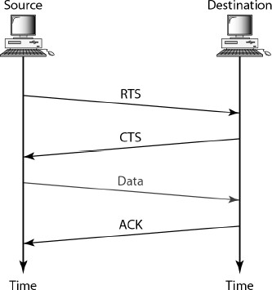
  - length of the data to be sent/received
- The receiver sends an ACK to the sender after successfully receiving a frame.
- All nodes must wait for this ACK before trying to transmit.

- When two or more nodes detect an idle link and try to transmit an RTS frame at the same time, their RTS frames will collide with each other.
- 802.11 do not support collision detection, but instead, the senders realize the collision has happened when they do not receive the CTS frame after a period of time.
- Each node waits for a random amount of time before trying again.
- The amount of time a given node delays is defined by exponential back-off algorithm.

DISTRIBUTION SYSTEM IN WLAN / 802.11
In wireless network, nodes can move freely. Some nodes are allowed to roam and some are connected to a wired network infrastructure called access points (AP), and they are connected to each other by a so-called distribution system.
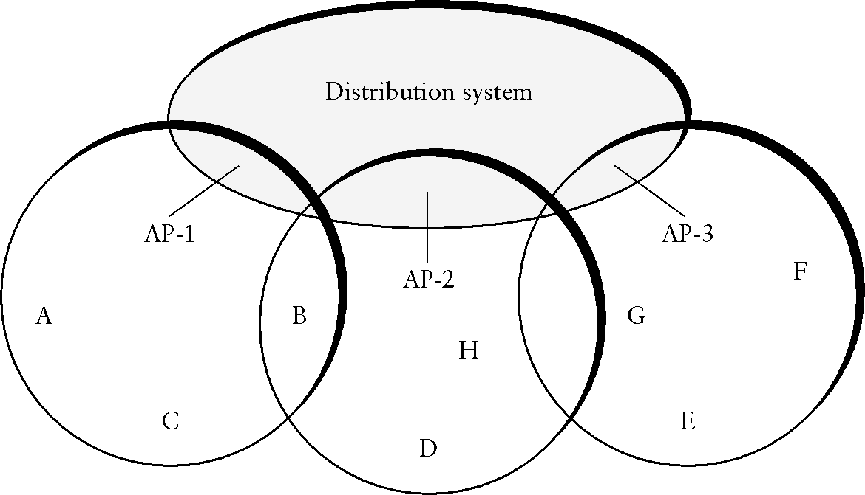

  - Two nodes can communicate directly with each other if they are within reach of each other,
  - When the nodes are at different range, for example when node A wish to communicate with node E, A first sends a frame to its access point (AP-1), which forwards the frame across the distribution system to AP-3, which finally transmits the frame to E.

Scanning Process in Distribution System
- The technique for selecting an Access Point is called scanning.
- Scanning will take place whenever a node joins the network as well as when it is not satisfied with the current access point signal.
- It involves the following four steps:
  - The node sends a Probe Request frame.
  - All AP’s within reach reply with a Probe Response frame.
  - The node selects one of the access points and sends that AP an
Association Request frame.

  - The AP replies with an Association Response frame.

- There are two types of Scanning. They are
  - Active Scanning
  - Passive Scanning

Active Scanning
When node C moves from the cell serviced by AP-1 to the cell serviced by AP-2. As it moves, it sends Probe frames, which eventually result in Probe Response. Since the node is actively searching for an access point it is called active scanning.
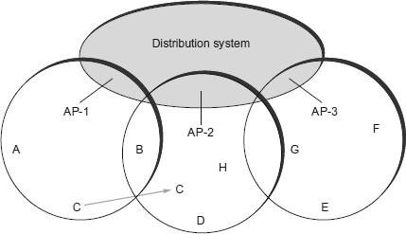

Passive Scanning
AP’s periodically send a Beacon frame to the nodes that advertises the capabilities of the access point which includes the transmission rates supported by the AP. This is called passive scanning and a node can change to this AP based on the Beacon frame simply by sending it an Association Request frame back to the access point.

FRAME FORMAT OF WLAN / 802.11
- Control field - contains three subfields :
- Type field - Indicates whether the frame carries data, RTS or CTS frame
- To DS - Data frame sent to DS
- From DS – ACK sent from DS

When both the DS bits are set to 0, it indicates that one node is sending directly to another . Addr l identifies the target node and Addr2 identifies the source node.

When both the DS bits are set to 1, it indicates that one node is sending the message to another indirectly using the distribution system.

- Duration - contains the duration of time the medium is occupied by the nodes.
- Addr l - identifies the final original destination
- Addr 2 - identifies the immediate sender (the one that forwarded the frame from the distribution system to the ultimate destination)
- Addr 3 - identifies the intermediate destination (the one that accepted the frame from a wireless node and forwarded it across the distribution system)
  - Addr 4 - identifies the original source
  - Sequence Control - to avoid duplication of frames sequence number is
assigned to each frame
  - Payload - Data from sender to receiver
  - CRC - used for Error detection of the frame.

8. WIRED LAN : ETHERNET (IEEE 802.3)
• Ethernet was developed in the mid-1970’s at the Xerox Palo Alto Research
Center (PARC),
• IEEE controls the Ethernet standards.
• The Ethernet is the most successful local area networking technology, that
uses bus topology.
• The Ethernet is multiple-access networks that is set of nodes send and
receive frames over a shared link.
• Ethernet uses the CSMA / CD ( Carrier Sense Multiple Access with
Collision Detection) mechanism.

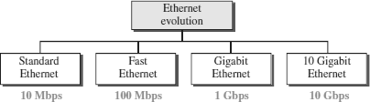
EVOLUTION OF ETHERNET
Ethernet.
Standard Ethernet (10 Mbps)
The original Ethernet technology with the data rate of 10 Mbps as the Standard Ethernet.
Standard Ethernet types are:
10Base5: Thick Ethernet,
10Base2: Thin Ethernet ,
10Base-T: Twisted-Pair Ethernet
10Base-F: Fiber Ethernet.

10Base5: Thick Ethernet  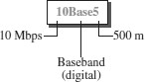  - The first implementation is called 10Base5, thick Ethernet, or Thicknet.  - 10Base5 was the first Ethernet specification to use a bus topology with an external transceiver(transmitter/receiver) connected via a tap to a thick coaxial cable. | 10Base2: Thin Ethernet  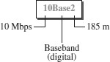  - The second implementation is called 10Base2, thin Ethernet, or Cheapernet.  - 10Base2 also uses a bus topology, but the cable is much thinner and more flexible.  - In this case, the transceiver is normally part of the network interface card (NIC), which is installed inside the station.
10Base-T: Twisted-Pair Ethernet  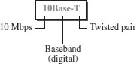  - The third implementation is called  10Base-T or twisted-pair Ethernet.  - 10Base-T uses a physical star topology. The stations are connected to a hub via two pairs of twisted cable. | 10Base-F: Fiber Ethernet  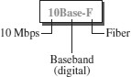  - Although there are several types of optical fiber 10-Mbps Ethernet, the most common is called 10Base-F.  - 10Base-F uses a star topology to connect stations to a hub.  - The stations are connected to the hub using two fiber-optic cables.

Fast Ethernet (100 Mbps)

Fast Ethernet or 100BASE-T provides transmission speeds up to 100 megabits per second and is typically used for LAN backbone systems.
The 100BASE-T standard consists of three different component specifications –
- 100 BASE-TX
- 100BASE-T4
- 100BASE-FX

100 BASE-TX | 100BASE-T4 | 100BASE-FX
100Base-TX uses two pairs of twisted-pair cable either UTP or STP. A 100Base-TX network can provide a data rate of 100 Mbps. | A new standard, called 100Base-T4, was designed to use four pairs of UTP for transmitting 100 Mbps. | 100Base-FX uses two pairs of fiber-optic cables. Optical fiber can easily handle high bandwidth requirements.

Gigabit Ethernet (1 Gbps)
  - The Gigabit Ethernet upgrades the data rate to 1 Gbps(1000 Mbps).
  - Gigabit Ethernet can be categorized as either a two-wire or a four-wire implementation.
  - The two-wire implementations use fiber-optic cable (1000Base-SX, short- wave, or 1000Base-LX, long-wave), or STP (1000Base-CX).
  - The four-wire version uses category 5 twisted-pair cable (1000Base-T).

10 Gigabit Ethernet(10 Gbps)
- 10 Gigabit Ethernet is an upcoming Ethernet technology that transmits at 10 Gbps.
- 10 Gigabit Ethernet enables a familiar network technology to be used in LAN, MAN and WAN architectures.
- 10 Gigabit Ethernet uses multimode optical fiber up to 300 meters and single mode fiber up to 40 kilometers.
- Four implementations are the most common: 10GBase-SR, 10GBase-LR, 10GBase-EW, and 10GBase-X4.

ACCESS METHOD/ PROTOCOL OF ETHERNET
The access method of Ethernet is CSMA/CD.

Note : Refer CSMA/CD from MAC

COLLISION DETECTION IN ETHERNET
  - As the Ethernet supports collision detection, senders are able to determine a collision.
  - At the moment an adaptor detects that its frame is colliding with another, it first makes sure to transmit a 32-bit jamming sequence along with the 64- bit preamble (totally 96 bits) and then stops the transmission.
  - These 96 bits are sometimes called Runt Frame.

FRAME FORMAT OF ETHERNET
The Ethernet frame is defined by the format given in the Fig.

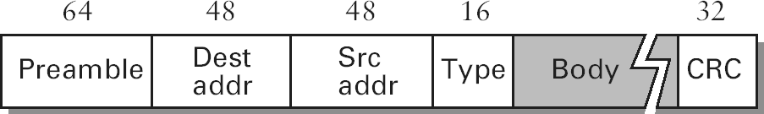

- The 64-bit preamble allows the receiver to synchronize with the signal; it is a sequence of alternating 0’s and 1’s.
- Both the source and destination hosts are identified with a 48-bit address.
- The packet type field serves as the demultiplexing key.
- Each frame contains up to 1500 bytes of data(Body).
- CRC is used for Error detection

Ethernet Addresses
- Every Ethernet host has a unique Ethernet address (48 bits – 6 bytes).
- Ethernet address is represented by sequence of six numbers separated by colons.
- Each number corresponds to 1 byte of the 6 byte address and is given by pair of hexadecimal digits.
- Eg: 8:0:2b:e4:b1:2 is the representation of
00001000 00000000 00101011 11100100 10110001 00000010
- Each frame transmitted on an Ethernet is received by every adaptor connected to the Ethernet.
- In addition to unicast addresses an Ethernet address consisting of all 1s is treated as broadcast address.
- Similarly the address that has the first bit set to 1 but it is not the broadcast address is called multicast address.

i

ADVANTAGES OF ETHERNET
Ethernets are successful because
- It is extremely easy to administer and maintain. There are no switches that can fail, no routing or configuration tables that have to be kept up-to-date, and it is easy to add a new host to the network.

- It is inexpensive: Cable is cheap, and the only other cost is the network adaptor on each host.
1. PHYSICAL LAYER
The physical layer coordinates the functions required to transmit a bit stream over a
physical medium.
The physical layer is concerned with the following functions:
➢ Physical characteristics of interfaces and media - The physical layer defines
the characteristics of the interface between the devices and the transmission
medium.
➢ Representation of bits - To transmit the stream of bits, it must be encoded to
signals. The physical layer defines the type of encoding.
➢ Signals: It determines the type of the signal used for transmitting the information.
➢ Data Rate or Transmission rate - The number of bits sent each second –is also
defined by the physical layer.
➢ Synchronization of bits - The sender and receiver must be synchronized at the
bit level. Their clocks must be synchronized.
➢ Line Configuration - In a point-to-point configuration, two devices are
connected together through a dedicated link. In a multipoint configuration, a link
is shared between several devices.
➢ Physical Topology - The physical topology defines how devices are connected to
make a network. Devices can be connected using a mesh, bus, star or ring
topology.

➢ Transmission Mode - The physical layer also defines the direction of
transmission between two devices: simplex, half-duplex or full-duplex.

TRANSMISSION MEDIA:
- Transmission media is a communication channel that carries the information from the sender to the receiver.
- Data is transmitted through the electromagnetic signals.
The main functionality of the transmission media is to carry the information in the form of bits (Either as Electrical signals or Light pulses).
- It is a physical path between transmitter and receiver in data communication.
- The characteristics and quality of data transmission are determined by the characteristics of medium and signal.

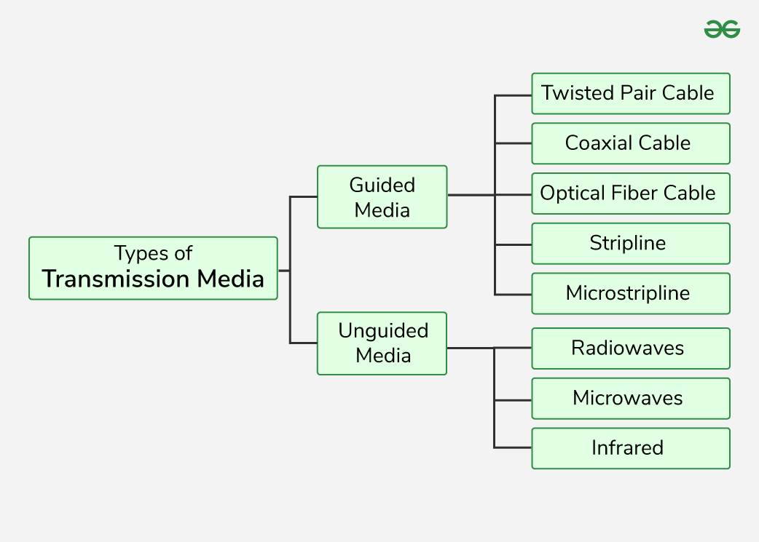

Guided Media
Guided Media is also referred to as Wired or Bounded transmission media. Signals being transmitted are directed and confined in a narrow pathway by using physical links.
Features:
High Speed
Secure
Used for comparatively shorter distances
Twisted Pair Cable
It consists of 2 separately insulated conductor wires wound about each other. Generally, several such pairs are bundled together in a protective sheath. They are the most widely used Transmission Media. Twisted Pair is of two types:
Unshielded Twisted Pair (UTP): UTP consists of two insulated copper wires twisted around one another. This type of cable has the ability to block interference and does not depend on a physical shield for this purpose. It is used for telephonic applications.
Shielded Twisted Pair (STP): This type of cable consists of a special jacket (a copper braid covering or a foil shield) to block external interference. It is used in fast-data-rate Ethernet and in voice and data channels of telephone lines.
Coaxial Cable
It has an outer plastic covering containing an insulation layer made of PVC or Teflon and 2 parallel conductors each having a separate insulated protection cover. The coaxial cable transmits information in two modes: Baseband mode(dedicated cable bandwidth) and Broadband mode(cable bandwidth is split into separate ranges). Cable TVs and analog television networks widely use Coaxial cables.
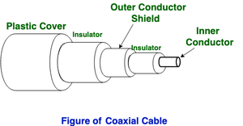
Optical Fiber Cable
Optical Fibre Cable uses the concept of refraction of light through a core made up of glass or plastic. The core is surrounded by a less dense glass or plastic covering called the cladding. It is used for the transmission of large volumes of data. The cable can be unidirectional or bidirectional. The WDM (Wavelength Division Multiplexer) supports two modes, namely unidirectional and bidirectional mode.
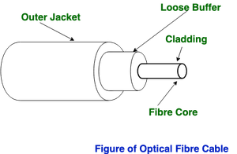
Stripline
Stripline is a transverse electromagnetic (TEM) transmission line medium invented by Robert M. Barrett of the Air Force Cambridge Research Centre in the 1950s. Stripline is the earliest form of the planar transmission line. It uses a conducting material to transmit high-frequency waves it is also called a waveguide. This conducting material is sandwiched between two layers of the ground plane which are usually shorted to provide EMI immunity.
Microstripline
In this, the conducting material is separated from the ground plane by a layer of dielectric.
2. Unguided Media
It is also referred to as Wireless or Unbounded transmission media . No physical medium is required for the transmission of electromagnetic signals.
Radio Waves
Radio waves are easy to generate and can penetrate through buildings. The sending and receiving antennas need not be aligned. Frequency Range:3KHz – 1GHz. AM and FM radios and cordless phones use Radio waves for transmission.
Microwaves
It is a line of sight transmission i.e. the sending and receiving antennas need to be properly aligned with each other. The distance covered by the signal is directly proportional to the height of the antenna. Frequency Range:1GHz – 300GHz. Micro waves are majorly used for mobile phone communication and television distribution.
Infrared
Infrared waves are used for very short distance communication. They cannot penetrate through obstacles. This prevents interference between systems. Frequency Range:300GHz – 400THz. It is used in TV remotes, wireless mouse, keyboard, printer, etc.

SWITCHING
  - The technique of transferring the information from one computer network to another network is known as switching.
  - Switching in a computer network is achieved by using switches.
  - A switch is a small hardware device which is used to join multiple computers together with one local area network (LAN).
  - Switches are devices capable of creating temporary connections between two or more devices linked to the switch.
  - Switches are used to forward the packets based on MAC addresses.
  - A Switch is used to transfer the data only to the device that has been addressed. It verifies the destination address to route the packet appropriately.
  - It is operated in full duplex mode.
  - It does not broadcast the message as it works with limited bandwidth.

Advantages of Switching:
  - Switch increases the bandwidth of the network.
  - It reduces the workload on individual PCs as it sends the information to only that device which has been addressed.
  - It increases the overall performance of the network by reducing the traffic on the network.
  - There will be less frame collision as switch creates the collision domain for each connection.

Disadvantages of Switching:
  - A Switch is more expensive than network bridges.
  - A Switch cannot determine the network connectivity issues easily.
  - Proper designing and configuration of the switch are required to handle multicast packets.

Types of Switching Techniques

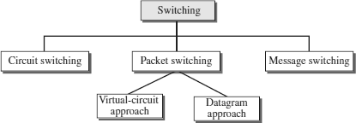

CIRCUIT SWITCHING

  - Circuit switching is a switching technique that establishes a dedicated path between sender and receiver.
  - In the Circuit Switching Technique, once the connection is established then the dedicated path will remain to exist until the connection is terminated.
  - Circuit switching in a network operates in a similar way as the telephone works.
  - A complete end-to-end path must exist before the communication takes place.
  - In case of circuit switching technique, when any user wants to send the data, voice, video, a request signal is sent to the receiver then the receiver sends back the acknowledgment to ensure the availability of the dedicated path. After receiving the acknowledgment, dedicated path transfers the data.
  - Circuit switching is used in public telephone network. It is used for voice transmission.
  - Fixed data can be transferred at a time in circuit switching technology.

Phases in Circuit Switching
Communication through circuit switching has 3 phases:

- Connection Setup / Establishment - In this phase, a dedicated circuit is established from the source to the destination through a number of intermediate switching centres. The sender and receiver transmits communication signals to request and acknowledge establishment of circuits.

- Data transfer - Once the circuit has been established, data and voice are transferred from the source to the destination. The dedicated connection remains as long as the end parties communicate.

- Connection teardown / Termination - When data transfer is complete, the connection is relinquished. The disconnection is initiated by any one of the user. Disconnection involves removal of all intermediate links from the sender to the receiver.
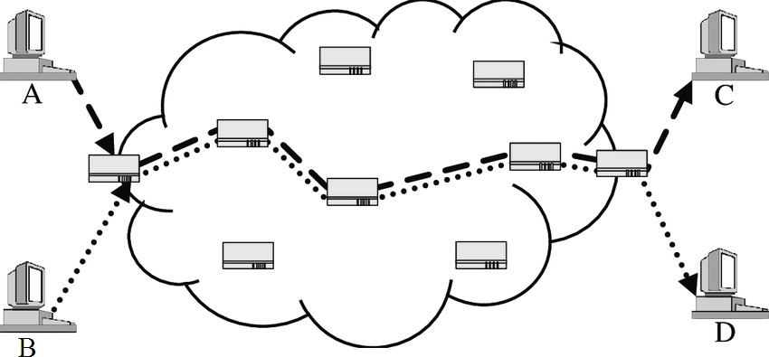

Advantages
- It is suitable for long continuous transmission, since a continuous transmission route is established, that remains throughout the conversation.
- The dedicated path ensures a steady data rate of communication.
- No intermediate delays are found once the circuit is established. So, they are suitable for real time communication of both voice and data transmission.

Disadvantages
- Circuit switching establishes a dedicated connection between the end parties. This dedicated connection cannot be used for transmitting any other data, even if the data load is very low.
- Bandwidth requirement is high even in cases of low data volume.
- There is underutilization of system resources. Once resources are allocated to a particular connection, they cannot be used for other connections.
- Time required to establish connection may be high.
- It is more expensive than other switching techniques as a dedicated path is required for each connection.

Part – C (Answers)
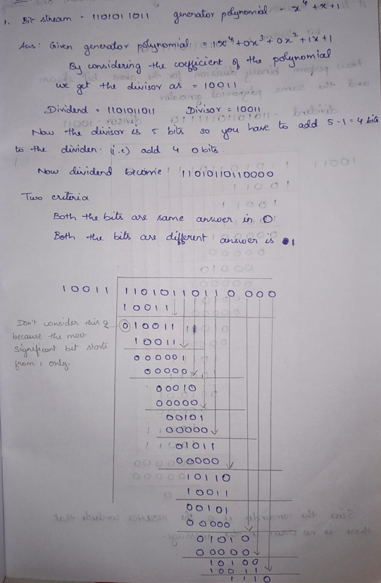
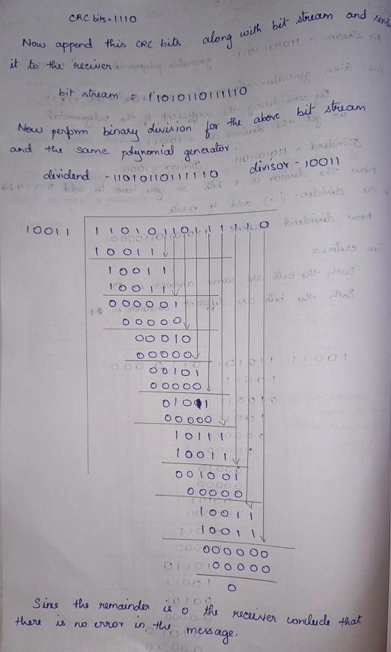

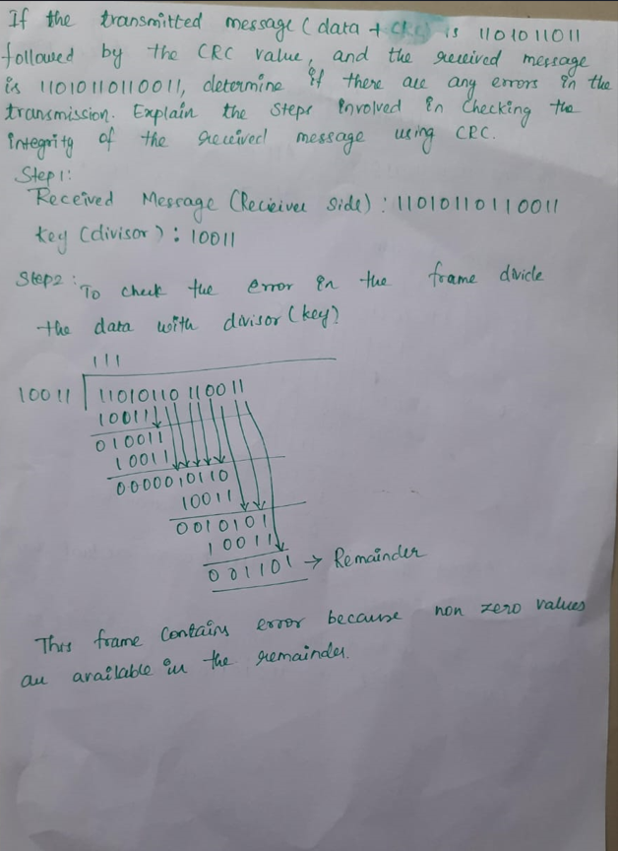
1``

